Phase 1
Elder Care Agent

Name | ID
Ahmed Ali Ali Mahmoud | 20200031
omar salah eldin ahmed ahmed | 20200347
Ibrahim Hisham ahmed | 20200005
Ali Maher Abdelaziz | 20200332
Abdelrahman Ahmed Samir Ahmed | 20200278

Stage#1:

1) Problem definition and Planning:
The elderly care robot is designed for elderly people and takes care of them and their health. As it lives with them in the same place and simulate the Work of a nurse as it gives the patient his medicine in the right time and provides them with good health care.
-The need of the agent:
- Eating
- Moving
- Hygiene
- Health care
- Taking medicine
- Communication
- Entertainment

2) Environment type:
-Man made environment.
-with properties :
- Deterministic
- Episodic
- Discrete
- Accessible
- Static
3) Agent type:
- LOGIC-BASED AGENTS (Single Agent)
4) PEAS:
- Performance
- Battery life
- Quickley response
- Health
- Accuracy of treatment appointment
- Memory size
- Environment
- Hospital
- Elderly home
- Actuator
- Monitor
- Wheels
- Arms
- Pressure measuring tool
- Blood Glucose Monitor
- Sensors
- Monitor
- Camera
- Ultrasonic
- Thermometer
- Pressure sensor

Stage#2:

- Problem state space:
-Actions:
- Up
- Down
- Right
- Left
- Recharge battery
- Giving and Taking Medicine
- Measure blood pressure
- Measure Blood Glucose
- Measure temperature

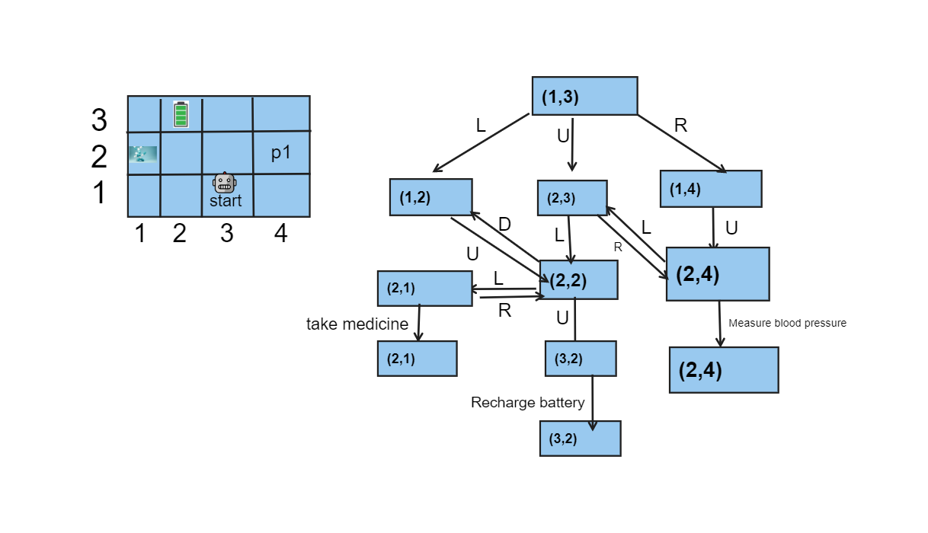
-State graph:
R

- Initial state: (1,3)
- Goal states
- Battery charge.
- Get medicine and drive it to the patient.
- Blood Pressure, Blood Glucose and Temperature measured.

- Successor function (Set of actions and paths costs):
- To charge the robot from Start (1,3) to Battery Charger (3,2).
- From (1,3) move left to (1,2)
- From (1,2) move up to (2,2)
- From (2,2) move up to (3,2)
- Start charging battery.
- Go to patient from Start (1,3) to patient (2,4)
- From (1,3) move up to (2,3)
- From (2,3) move right to (2,4)
- Measure any tests for patient and make some Entertainment
- Go to take Medicines from Start (1,3) to Medicine Room (2,1)
- from (1,3) move up (2,3)
- from (2,3) move left (2,2)
- from (2,2) move left (2,1)
- take medicals
- Go to Patient to give him the Medicine.
- If the robot has the medical
- move right (1,3) to (1 ,4)
- move up (1,4) to (2,4)
- give him the medical
2-Else
- go to step 3 to take medical
- go right (2,1) to (2,2)
- Go right (2,2) to (2,3)
- Go right from (2,3) to (2,4)
- Give him the medical
-And the last step in each step is the Actions.
- Transition function
- Result ((2,3), Right) = (2,4)
- Result ((2,4), Measure blood pressure) = (2,4)

- Solution/plan (Show Transformation from Initial state to Goal state):
- To charge the robot from Start point (1,3) to Battery Charger point (3,2):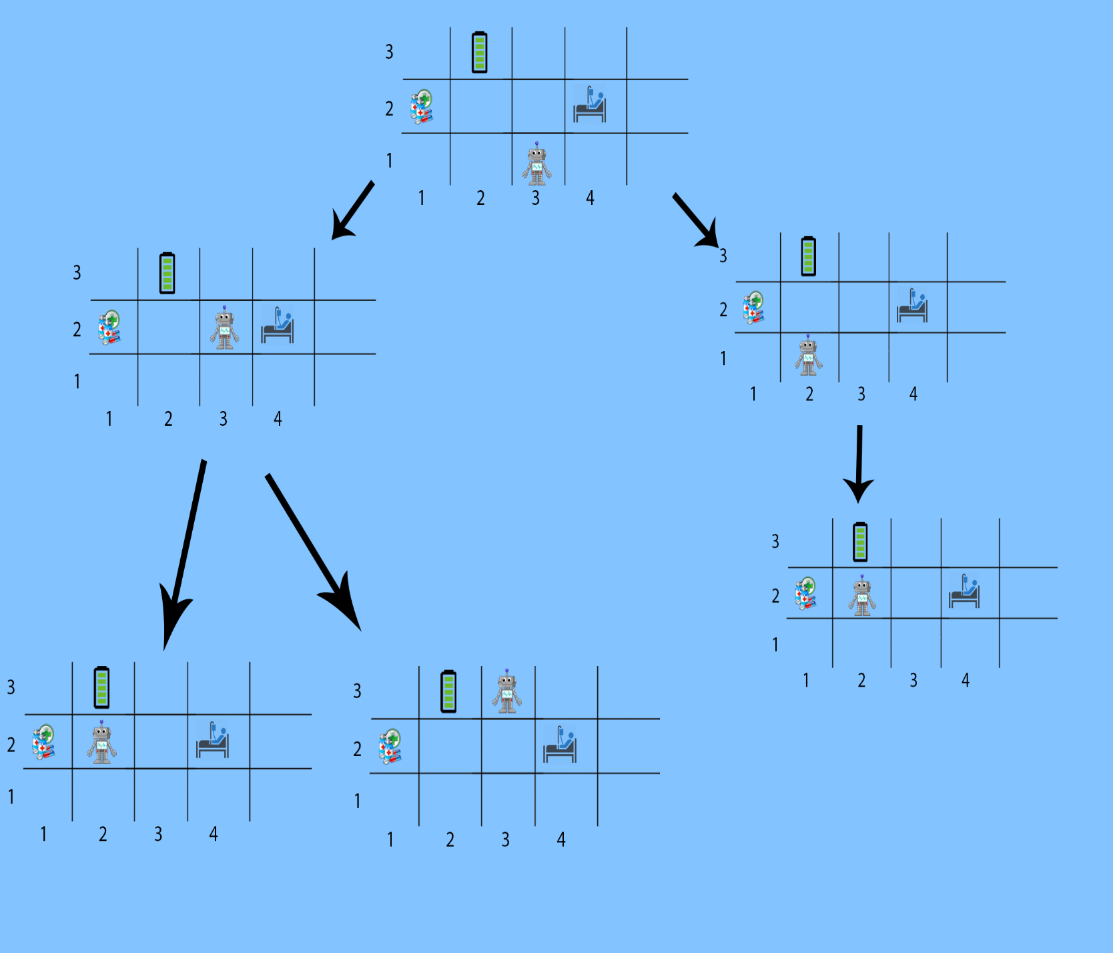

- Robots go to patient from Start point (1,3) to patient point (2,4)
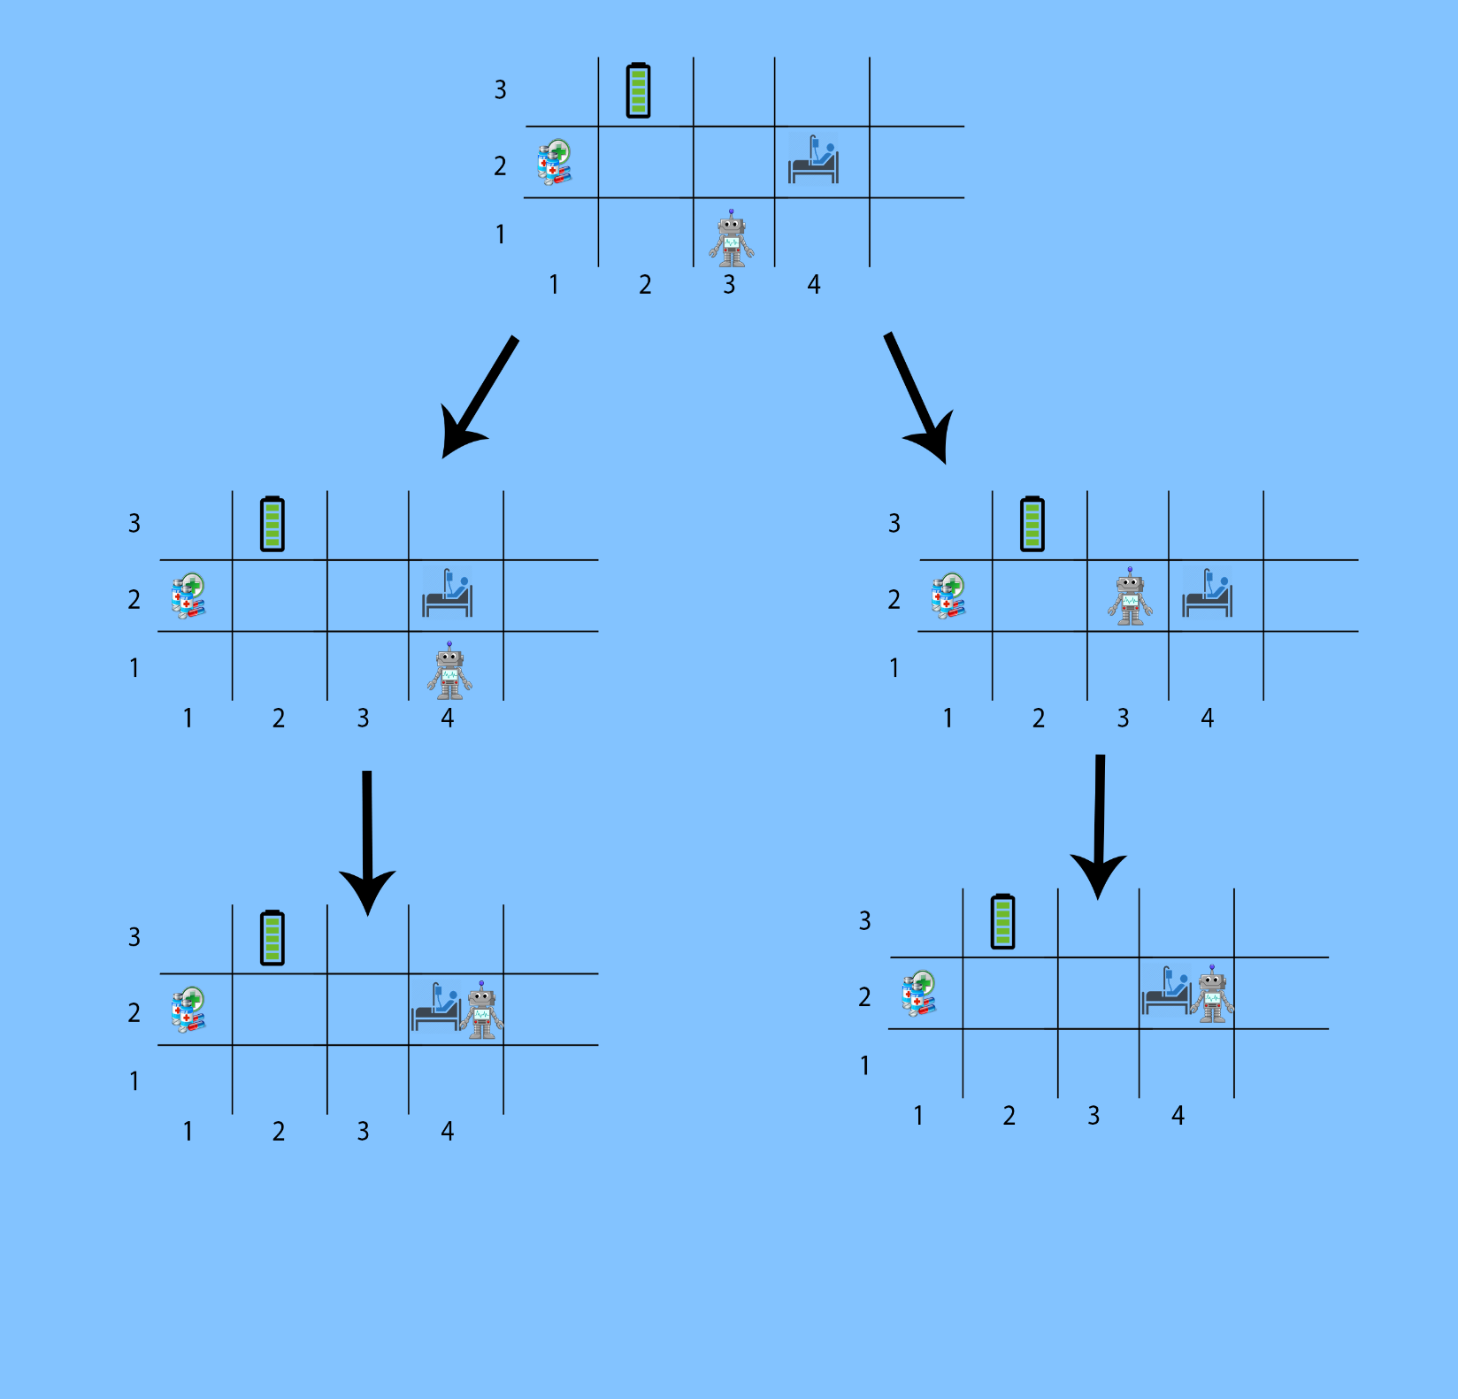

- Robot go to take Medicines, moves from Start (1,3) to Medicine Room (2,1) 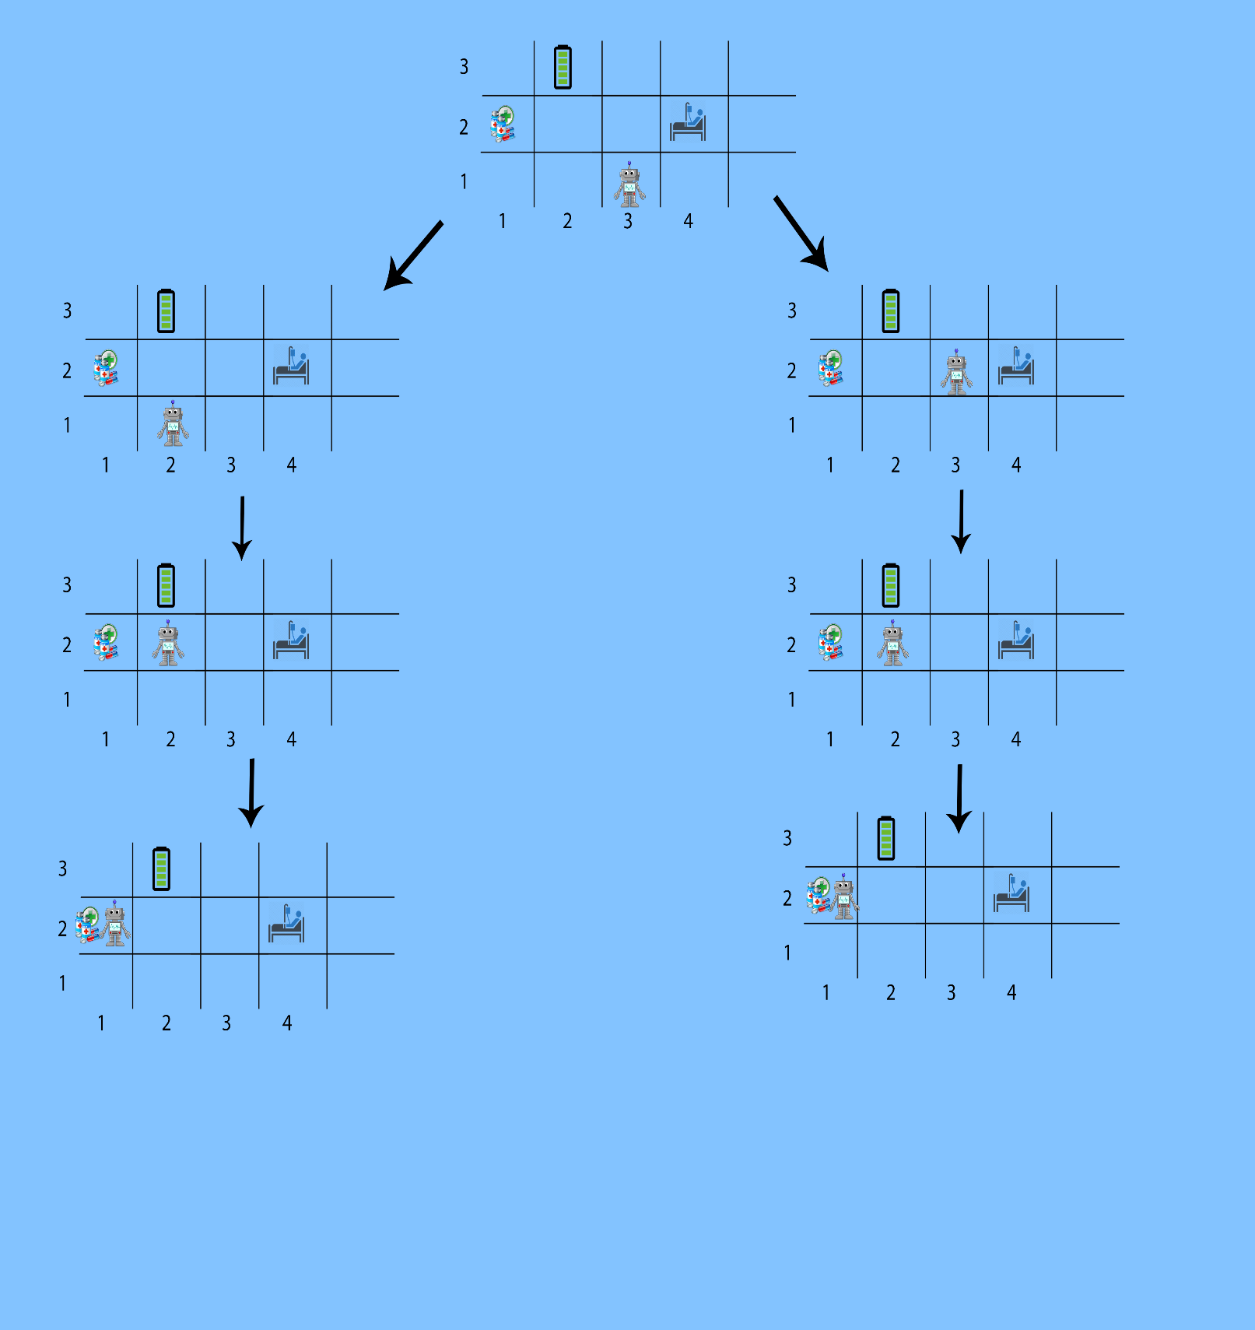

- Robot goes to give the medicine to the patient in case the robot already has it.
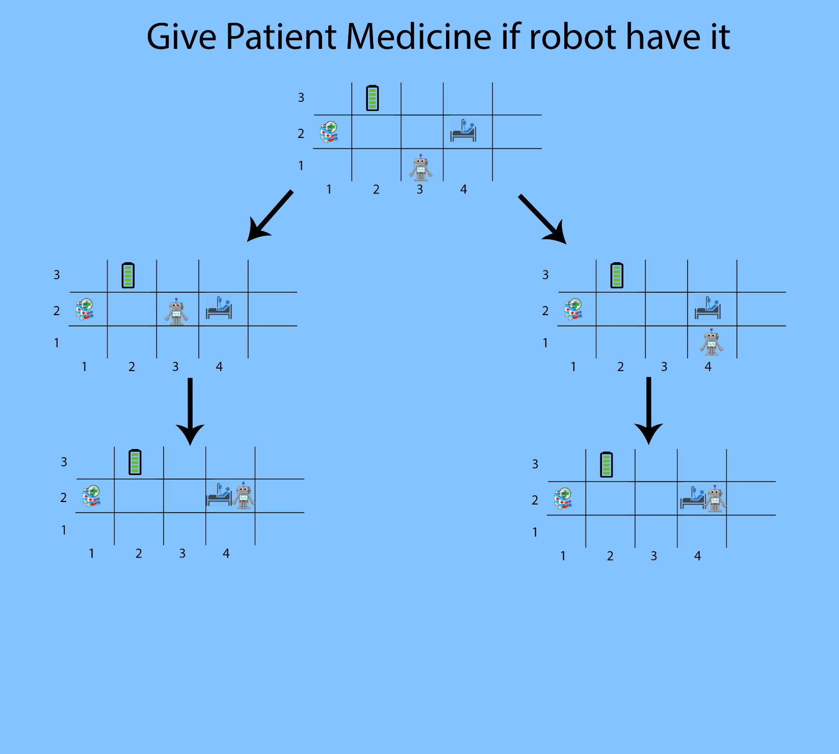

- Robot goes to give the medicine to the patient in case the robot doesn’t have it.
